Exercise 2 memo

#2

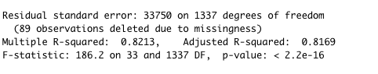

* Is there a relationship between the predictors and the response?
* p-value equal to 2.2\*e^16, which is very small. So, this regression is very accuracy.
* Which predictors appear to have a statistically significant relationship to the response?
* It is a statistically significant relationship between predictors and response. Since p-value = 2.2\*e^-16 <0.05.
* What does the coefficient for the year variable suggest?
* the coefficient for the year variable is 3.965\*e+02, which implies that every one-year increase, the Sale Price increase by 3.95\*e^2.

#3

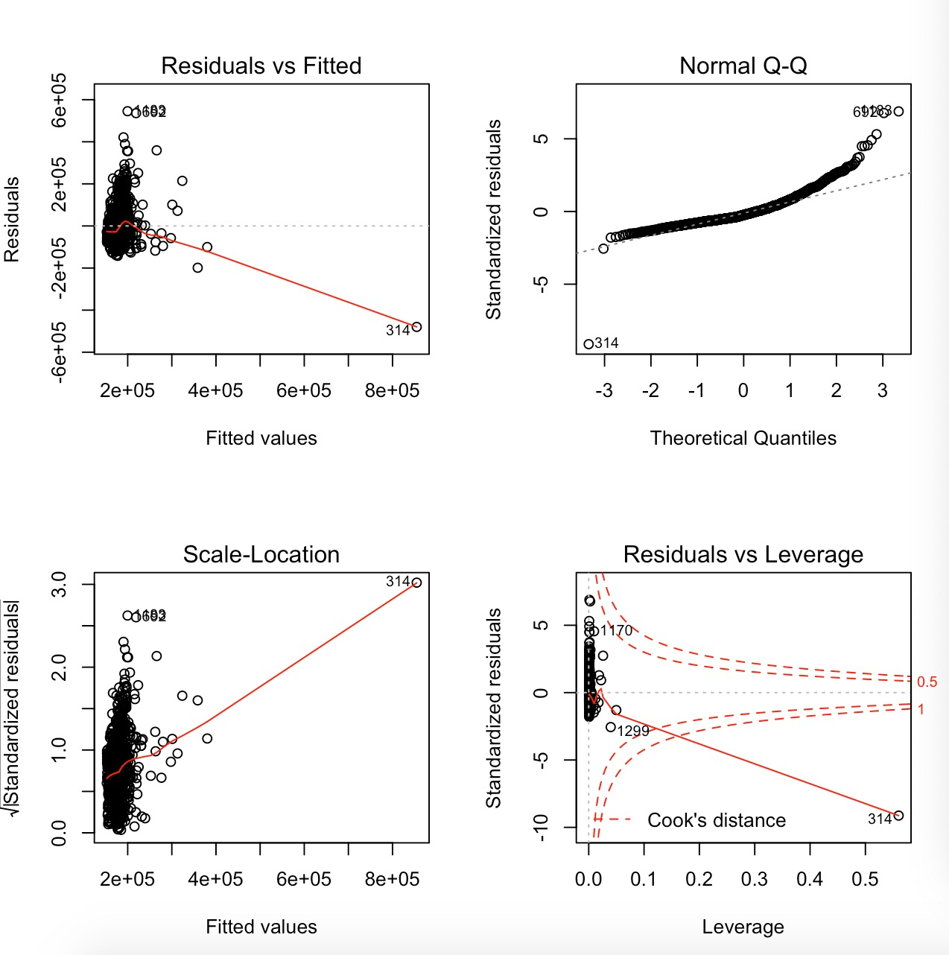

* Do the residual plots suggest any unusually large outliers?
* There is a large residual, which is 1602.
* Does the leverage plot identify any observations with unusually high leverage?
* There is a very high leverage, which is 0.5

#4

the \* operator gives the multiplicative term as well as the first order terms, and the: operator just gives the multiplicative term.

They both give the same results.

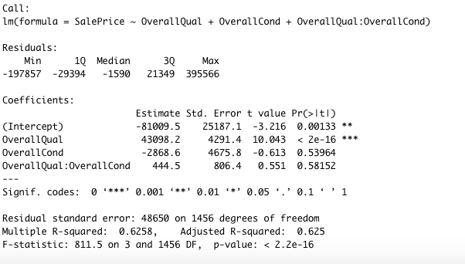

#5

* Do any of these make sense to include in a model of SalePrice?

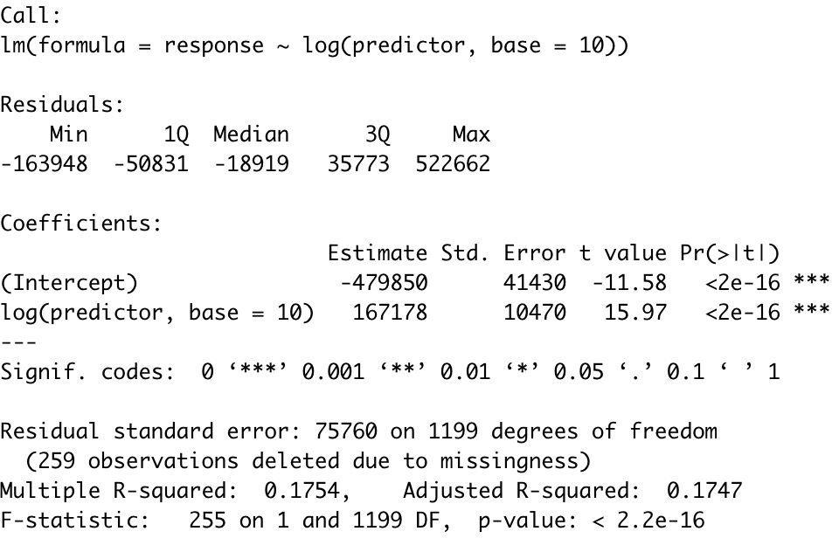

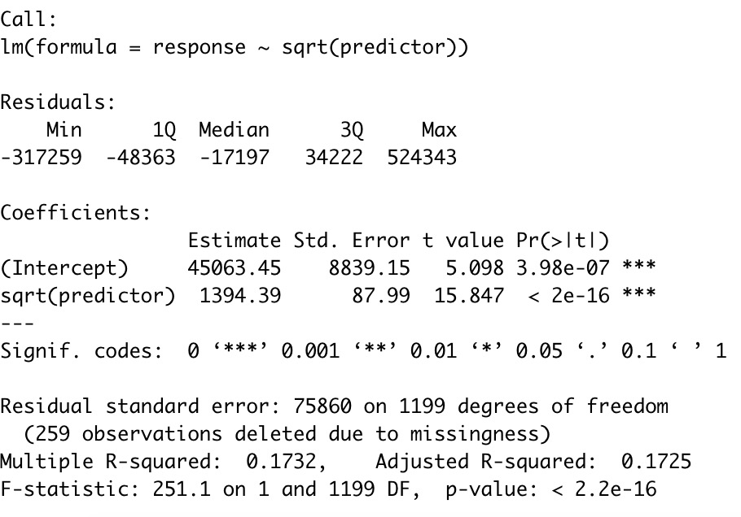

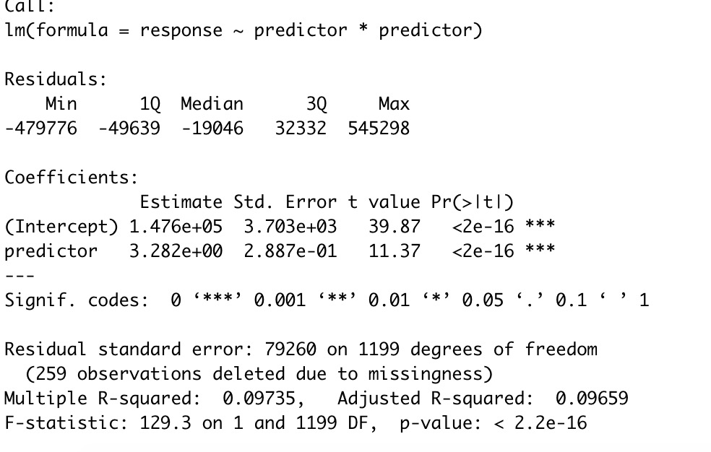

These do not make sense to the model of SalePrice because they have changed the data itself and both results show statistically significant here to SalePrice. However, this does not mean that the data itself is highly correlated with SalePrice.